**DBMS WEEK 2 OUTPUTS:**

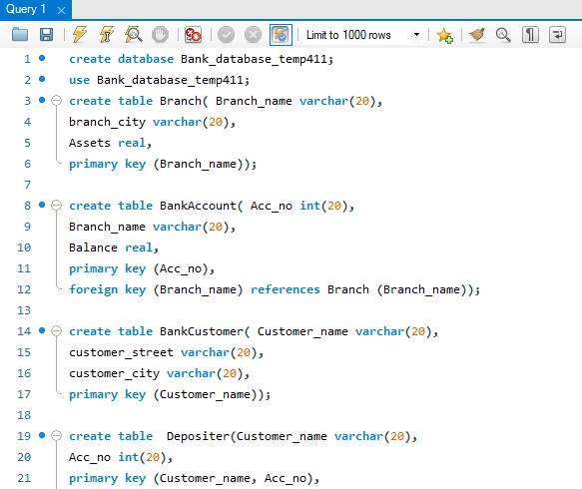

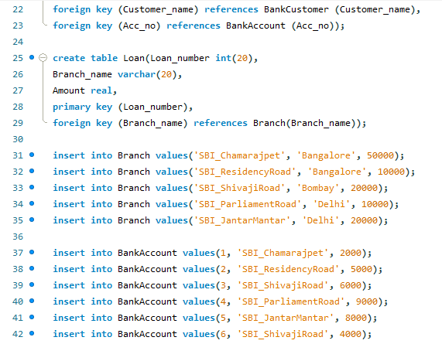

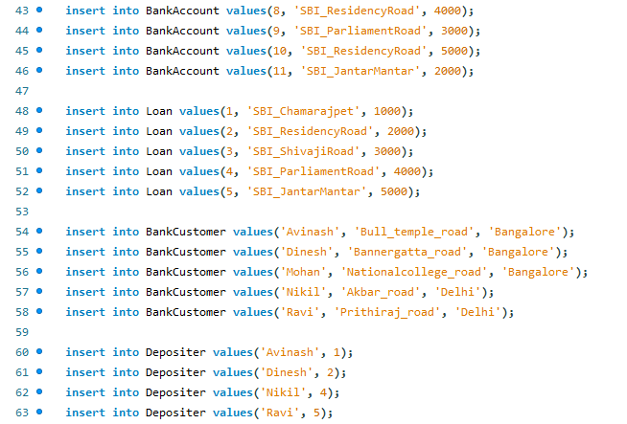

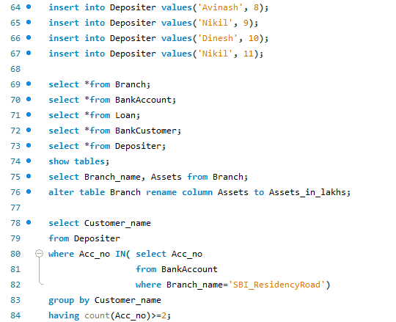

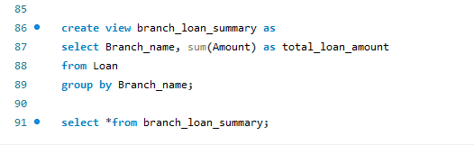

* **Show tables;**

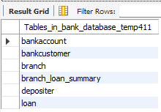

* **select *from Branch;**

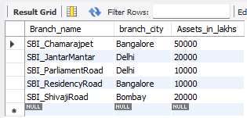

* **select *from BankAccount;**

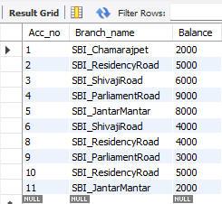

* **select *from Loan;**

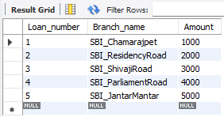

* **select *from BankCustomer;**

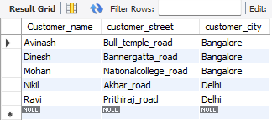

* **select *from Depositer;**

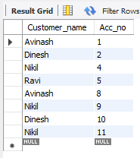

* **select Branch_name, Assets from Branch;**

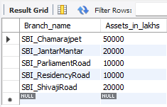

* select Customer_name

from Depositer

where Acc_no IN( select Acc_no

from BankAccount

where Branch_name='SBI_ResidencyRoad')

group by Customer_name

having count(Acc_no)>=2;

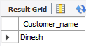

* create view branch_loan_summary as

select Branch_name, sum(Amount) as total_loan_amount

from Loan

group by Branch_name;

select *from branch_loan_summary;

